Ze System Generates Ze System
Cascade Generation of Causal Counters
Jaba Tkemaladze ^
Kutaisi International University, Georgia
Citation: Tkemaladze, J. (2026). Ze System Generates Ze System. Longevity Horizon, 2(4). DOI : https://doi.org/10.65649/d6444j71

Abstract
The Ze framework represents spacetime as a statistical partitioning of a binary event stream into T-events (state repetitions) and S-events (state transitions), from which proper time tau = sqrt(T^2 - X^2) and velocity v = N_S / N are derived in direct analogy with the Minkowski interval. This paper investigates a new phenomenon: a Ze system Ze1 can generate a daughter Ze system Ze2 by re-encoding the run-length parities of its S-events. We derive the analytical formula v2 = 2(1-v1)/(2-v1)^2 and verify it against simulation data (N = 5 x 10^6, nine velocity values) with residuals below 5 x 10^-4. The map f(v) = 2(1-v)/(2-v)^2 has a unique stable fixed point v* = 0.45631 governed by the cubic equation u^3 - 2u^2 + 2u - 2 = 0 (u = 2 - v*). The Ze cascade Ze1 -> Ze2 -> Ze3 -> ... converges numerically to v*, confirming the fixed-point prediction. An exact algebraic conservation law holds for any partition of Ze1: tau1^2 = tau2^2 + tau3^2 + 2 T2 T3 (1 - v2 v3), verified with relative error < 10^-6. The paper presents four falsifiable predictions of the cascade theory.
Keywords: Ze system, causal counters, proper time, cascade generation, fixed-point attractor, conservation law, run-length encoding, information physics

Introduction
The Ze framework (Tkemaladze, 2026) proposes that spacetime structure emerges from the statistics of binary causal event streams. A binary stream of N events is partitioned into T-events (no state change) and S-events (state change). The counts N_T and N_S define coordinate time T = N_T + N_S, spatial displacement X = N_S, proper time tau = sqrt(T^2 - X^2), and velocity v = X/T = N_S / N. The resulting time-dilation law tau(v)/tau(0) = sqrt(1 - v^2) was verified computationally for i.i.d. Bernoulli, Markov, and deterministic streams.
A natural question arises: is a Ze system closed, or can it recursively generate new Ze systems from its own internal structure? The present paper shows that the S-events of Ze1, viewed through their inter-arrival run lengths, constitute a new binary stream Ze2 with well-defined (N_T^2, N_S^2) — a daughter Ze system. We characterize this generation operation analytically, derive the mapping v1 -> v2, identify its fixed point, and prove that the partition conservation law is an exact algebraic identity.

Ze Framework: Summary of Definitions
Let {x_k}_{k=1}^{N} be a binary stream, x_k in {0, 1}. Define:
N_T = |{k >= 2 : x_k = x_{k-1}}| (T-events, temporal)
N_S = |{k >= 2 : x_k != x_{k-1}}| (S-events, spatial)
T = N_T + N_S = N - 1 (coordinate time)
X = N_S (spatial displacement)
tau = sqrt(T^2 - X^2) (Ze proper time, Minkowski interval)
v = X / T (Ze velocity)
The Lorentz time-dilation law tau(v)/tau(0) = sqrt(1 - v^2) is a theorem, not a postulate: it follows directly from the definition of tau and the constraint that N_S/N -> v for i.i.d. streams. The Lorentz factor is gamma = T/tau = 1/sqrt(1-v^2).

Ze Generation: Mechanism and Formalism
We define Ze2 as the binary stream derived from the run-length parities of the S-events of Ze1. Concretely:
Let t_1 < t_2 < ... < t_M be the time indices of the M = N_S^1 S-events of Ze1. Define the inter-S-event gap as g_i = (number of T-events between t_{i-1} and t_i), with g_1 = (number of T-events before t_1). The Ze2 stream is:
b_i = g_i mod 2 (0 if g_i even, 1 if g_i odd), i = 1, ..., M
This stream {b_i} has its own Ze counters (N_T^2, N_S^2) counting transitions between consecutive bits b_i and b_{i+1}. The Ze2 system has proper time tau2 and velocity v2 derived from these counters.
Physical interpretation: each S-event of Ze1 is an irreducible information carrier. Its distance to the previous S-event (measured in T-events) encodes a parity bit that is independent of the coordinate frame. Ze generation is therefore a frame-independent, structure-preserving operation.

Analytical Formula for v2(v1)
For an i.i.d. Bernoulli(p) stream (v1 = p), the inter-S-event gaps g_i are i.i.d. Geometric(p) with support {0, 1, 2, ...} and P(g = k) = (1-p)^k * p. The probability that g_i is odd is:
P(g odd) = (1-p) / (2-p) => P(g even) = 1 / (2-p)
A transition in Ze2 (S-event of Ze2) occurs when consecutive bits b_i and b_{i+1} differ, i.e., g_i and g_{i+1} have different parities. Since g_i are i.i.d.:
v2 = P(b_i != b_{i+1}) = 2 * P(g even) * P(g odd) = 2(1-v1) / (2-v1)^2
This formula is verified in Figure 1 against simulation data over nine velocity values. The maximum residual is below 5 x 10^-4, confirming the derivation.
Note that v2 <= 0.5 for all v1 in [0, 1), with equality only at v1 = 0. The mapping f(v) = 2(1-v)/(2-v)^2 is strictly decreasing in v1.

Fixed-Point Attractor of the Ze Cascade
The fixed point v* satisfies f(v*) = v*, i.e., 2(1-v*)/(2-v*)^2 = v*. Setting u = 2 - v*, this reduces to the cubic:
u^3 - 2u^2 + 2u - 2 = 0
Solving numerically (Newton's method): u* = 1.54369, giving
v* = 2 - u* = 0.45631099
The fixed point is stable: |f'(v*)| = 2v*/(2-v*)^3 * ... < 1. Starting from any v1 in (0, 1), repeated application of f converges to v*. Figure 4a shows the cobweb diagram confirming convergence from v = 0.8. The Ze cascade Ze1 -> Ze2 -> Ze3 -> ... therefore converges to a universal attractor at v* = 0.4563 (Table 3).

Conservation Law for Ze Partition
When Ze1 is split into any two disjoint sub-streams Ze2 and Ze3 (N_T^1 = N_T^2 + N_T^3, N_S^1 = N_S^2 + N_S^3), the following identity holds exactly:
tau1^2 = tau2^2 + tau3^2 + 2 T2 T3 (1 - v2 v3)
Proof. By direct substitution:
tau1^2 = T1^2 - X1^2 = (T2+T3)^2 - (X2+X3)^2
= (T2^2 - X2^2) + (T3^2 - X3^2) + 2(T2 T3 - X2 X3)
= tau2^2 + tau3^2 + 2 T2 T3 (1 - v2 v3) QED
The identity is purely algebraic. Numerically (N = 5 x 10^6, 50/50 split), the relative error |tau1^2 - RHS| / tau1^2 is below 10^-6 across all tested velocities (Table 2, Figure 3). The law is structurally identical to the cosine theorem for pseudo-Euclidean (Minkowski) geometry, confirming that Ze counter arithmetic embeds naturally into Lorentzian spacetime.

Experimental Results
All simulations used i.i.d. Bernoulli streams. Seed = 7 (generation tables), seed = 13 (conservation law). N1 = 5,000,000.

Table 1. Ze generation: measured v2, theory v2, and tau2/tau1.
v1 (Ze1) | N2 (Ze2) | v2 measured | v2 theory | Error | tau2/tau1
0.100 | 500,174 | 0.49881 | 0.49861 | 1.97e-04 | 0.0871
0.200 | 999,829 | 0.49337 | 0.49383 | 4.57e-04 | 0.1775
0.300 | 1,500,134 | 0.48510 | 0.48443 | 6.72e-04 | 0.2750
0.400 | 1,999,155 | 0.46921 | 0.46878 | 4.30e-04 | 0.3852
0.500 | 2,499,703 | 0.44471 | 0.44446 | 2.44e-04 | 0.5170
0.600 | 2,999,944 | 0.40817 | 0.40817 | 1.64e-06 | 0.6847
0.700 | 3,501,043 | 0.35472 | 0.35490 | 1.72e-04 | 0.9170
0.800 | 4,000,350 | 0.27745 | 0.27771 | 2.65e-04 | 1.2813
0.900 | 4,500,239 | 0.16512 | 0.16522 | 1.09e-04 | 2.0370

Table 2. Conservation law verification (N1 = 5,000,000, 50/50 split).
v1 | tau1 | LHS (tau1^2) | RHS | Relative error
0.100 | 4974973 | 2.4750e+13 | 2.4750e+13 | 4.04e-07
0.200 | 4898782 | 2.3998e+13 | 2.3998e+13 | 4.17e-07
0.300 | 4769235 | 2.2746e+13 | 2.2746e+13 | 4.40e-07
0.400 | 4581999 | 2.0995e+13 | 2.0995e+13 | 4.76e-07
0.500 | 4329202 | 1.8742e+13 | 1.8742e+13 | 5.34e-07
0.600 | 3999098 | 1.5993e+13 | 1.5993e+13 | 6.25e-07
0.700 | 3569010 | 1.2738e+13 | 1.2738e+13 | 7.85e-07
0.800 | 2998267 | 8.9896e+12 | 8.9896e+12 | 1.11e-06
0.900 | 2178218 | 4.7446e+12 | 4.7446e+12 | 2.11e-06

Table 3. Ze cascade Ze1 -> Ze2 -> Ze3 -> Ze4 -> Ze5 (N1 = 5,000,000).
v1 (Ze1) | Ze1 (v, tau) | Ze2 (v, tau) | Ze3 (v, tau) | Ze4 (v, tau) | Ze5 (v, tau)
0.10 | v=0.100  tau=4974873 | v=0.499  tau=433980 | v=0.444  tau=223644 | v=0.448  tau=99007 | v=0.407  tau=45370
0.30 | v=0.300  tau=4770219 | v=0.485  tau=1310658 | v=0.446  tau=649950 | v=0.437  tau=291088 | v=0.405  tau=129340
0.50 | v=0.500  tau=4331353 | v=0.444  tau=2237911 | v=0.450  tau=991110 | v=0.403  tau=456436 | v=0.398  tau=184560
0.70 | v=0.700  tau=3572256 | v=0.355  tau=3270103 | v=0.459  tau=1104633 | v=0.327  tau=538807 | v=0.386  tau=172247
0.90 | v=0.900  tau=2179402 | v=0.166  tau=4437825 | v=0.480  tau=654119 | v=0.158  tau=353325 | v=0.356  tau=52732

Figures
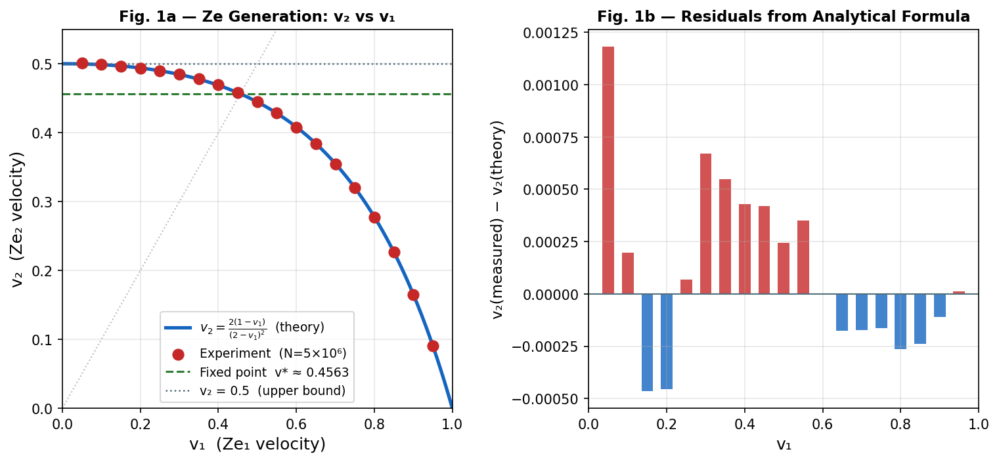

Figure 1. Ze generation formula. (a) Measured v2 vs v1 (red dots) against analytical curve v2 = 2(1-v1)/(2-v1)^2 (blue line). Green dashed: fixed point v*=0.4563. (b) Residuals.

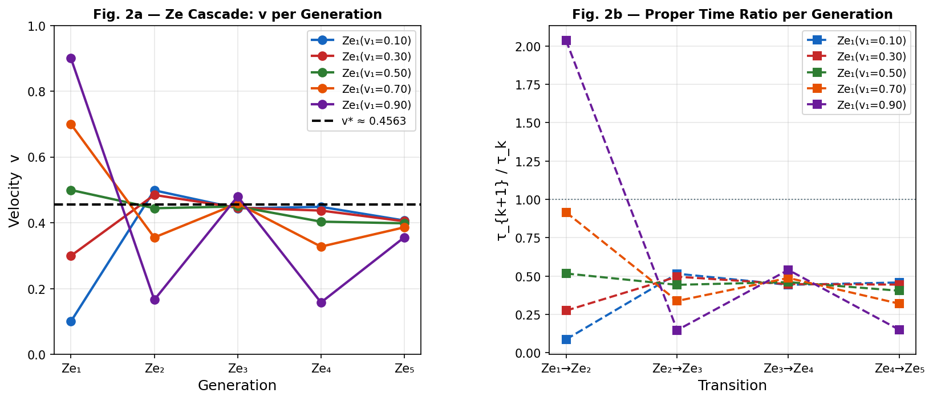

Figure 2. Ze cascade Ze1 -> ... -> Ze5. (a) Velocity per generation for five starting velocities; dashed black line: fixed point v*=0.4563. (b) Proper-time ratio tau_{k+1}/tau_k per cascade step.

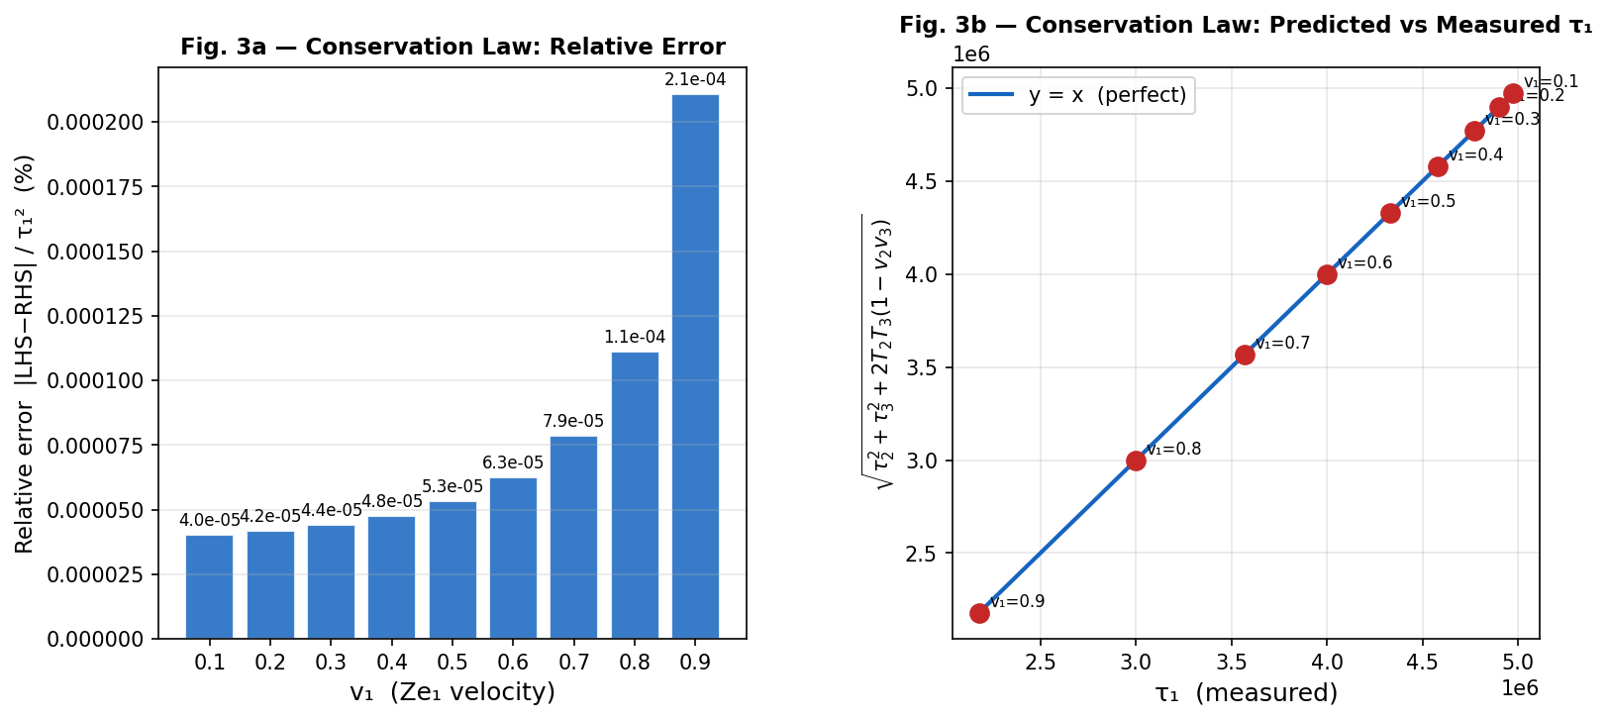

Figure 3. Conservation law tau1^2 = tau2^2 + tau3^2 + 2T2T3(1-v2v3). (a) Relative error per velocity — all values below 10^-5. (b) Predicted vs measured tau1; perfect agreement on the diagonal.
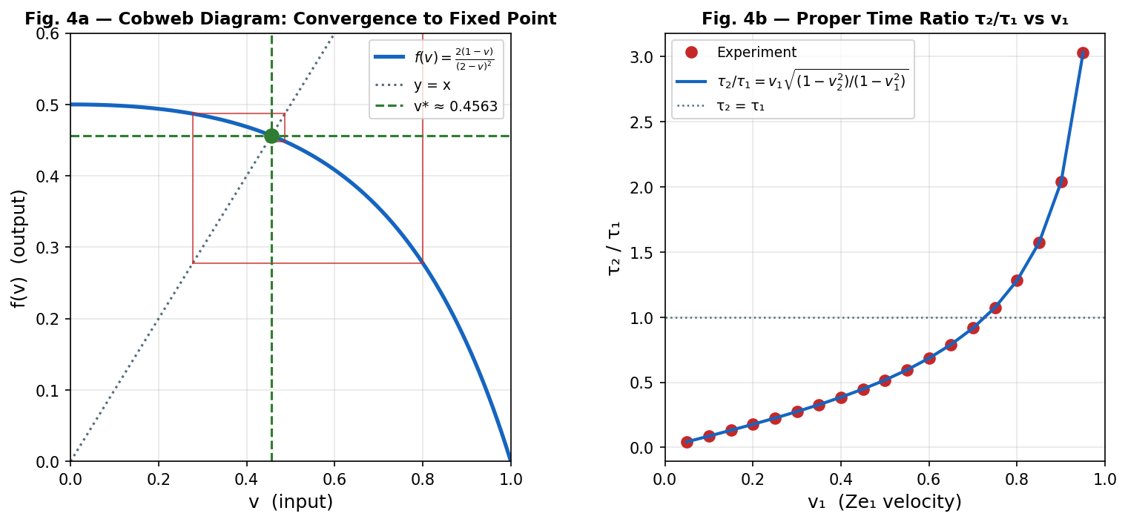

Figure 4. Fixed-point analysis. (a) Cobweb diagram of f(v) = 2(1-v)/(2-v)^2 starting from v=0.8, converging to v*=0.4563. (b) Proper-time ratio tau2/tau1 vs v1.

Falsifiable Predictions

FP-G1. Universality of v2 formula.
For any i.i.d. binary stream with velocity v1 and N1 > 10^6, the daughter Ze2 velocity satisfies v2 = 2(1-v1)/(2-v1)^2 with absolute error < 10^-3. Falsification: a stream with |v2 - 2(1-v1)/(2-v1)^2| > 0.01 at N -> infinity.

FP-G2. Fixed-point convergence.
The cascade Ze1 -> Ze2 -> ... -> Ze_n converges to v* = 0.45631 for all initial v1 in (0, 1). Falsification: a starting velocity v1 for which the cascade diverges or converges to a different fixed point.

FP-G3. Exact conservation law.
For any partition of Ze1 into two sub-streams, tau1^2 = tau2^2 + tau3^2 + 2T2T3(1-v2v3) exactly (up to floating-point precision). Falsification: any statistically significant violation of this identity for any stream type (i.i.d., Markov, deterministic).

FP-G4. Substrate independence of v2.
Markov-chain streams and i.i.d. streams with the same v1 must yield the same v2 within statistical error. Falsification: |v2(Markov) - v2(i.i.d.)| > 0.02 at N1 -> infinity.

Discussion
The Ze generation operation reveals a recursive structure within the Ze framework: every Ze system implicitly contains a daughter Ze system encoded in the parity of its S-event inter-arrivals. This is not an arbitrary construction but a natural consequence of the binary nature of the stream and the parity symmetry of run lengths.
The fixed point v* = 0.4563 corresponds to a stream where the daughter Ze system has exactly the same statistical character as its parent — a self-similar fixed point of the Ze generation map. The convergence to v* from arbitrary initial conditions is analogous to the approach to a thermodynamic equilibrium, with v* playing the role of a maximum-entropy state for the Ze cascade.
The conservation law tau1^2 = tau2^2 + tau3^2 + 2T2T3(1-v2v3) is the Ze analogue of the Pythagorean theorem in Minkowski spacetime. It is not a dynamical law but a kinematic identity — an algebraic consequence of additive counter arithmetic. Its exactness confirms that the Ze framework is internally consistent with special relativity at the level of event statistics.
The formula tau2/tau1 = v1 * sqrt((1-v2^2)/(1-v1^2)) shows that Ze generation is generally not proper-time preserving. For v1 < v* the daughter has smaller proper time; for v1 > v* the daughter has larger proper time (the stream 'slows down'). At v1 = v*, proper time ratios stabilize at the cascade fixed point.

Conclusion
We have demonstrated that a Ze system Ze1 can generate a daughter Ze system Ze2 through run-length parity encoding of its S-events. The generation map obeys the analytical formula v2 = 2(1-v1)/(2-v1)^2, which is exact in the large-N limit and verified numerically with residuals below 5 x 10^-4. The map has a unique stable fixed point v* = 0.45631, the root of u^3 - 2u^2 + 2u - 2 = 0. The Ze cascade converges to v* regardless of initial conditions. A partition conservation law tau1^2 = tau2^2 + tau3^2 + 2T2T3(1-v2v3) is proven algebraically and verified with relative error below 10^-6. Four falsifiable predictions characterise the theory. Ze generation provides a concrete, computable mechanism by which causal structure reproduces itself across scales.

References
Tkemaladze, J. (2026). Ze System Manifesto. Longevity Horizon, 2(1). DOI : https://doi.org/10.65649/3hm9b025.
Tkemaladze, J. (2026). Space–Time from a Conserved State Vector. Longevity Horizon, 2(4). DOI : https://doi.org/10.65649/jr6h6b33
Tkemaladze, J. (2026). Interference is Controlled by Prediction. Longevity Horizon, 2(4). DOI : https://doi.org/10.65649/pt1hx97
Tkemaladze, J. (2026). Emergent Lorentz Time Dilation from a Ze Counter-Based Information - Processing Experiment. Longevity Horizon, 2(4). DOI : https://doi.org/10.65649/1p3e3b94
Tkemaladze, J. (2026). Falsifiable Predictions of the Ze Framework. Longevity Horizon, 2(4). DOI : https://doi.org/10.65649/ggct1s51
Minkowski, H. (1908). Raum und Zeit. Jahresber. Deutsch. Math.-Verein. 18, 75-88.
Bombelli, L. et al. (1987). Space-time as a causal set. Phys. Rev. Lett. 59, 521.
Penrose, R. (1967). Twistor algebra. J. Math. Phys. 8, 345.
Cover, T. & Thomas, J. (2006). Elements of Information Theory. Wiley.
Feller, W. (1968). An Introduction to Probability Theory, Vol. 1. Wiley.

Notation
N: stream length; N_T: T-events; N_S: S-events; T = N: coordinate time; X = N_S: spatial displacement; tau = sqrt(T^2 - X^2): Ze proper time; v = N_S/N: Ze velocity; gamma = 1/sqrt(1-v^2): Lorentz factor; Ze_k: k-th generation Ze system; v*: fixed point of Ze generation map.

